# Price Basket Service

## Requirements

* The program should accept a list of items in the basket and output the subtotal, the special offer discounts and the final price.
* Input should be via the command line in the form PriceBasket item1 item2 item3
* The goods that can be purchased, which are all priced in GBP, are:
  + • Soup – 65p per tin
  + • Bread – 80p per loaf
  + • Milk – £1.30 per bottle
  + • Apples – £1.00 per bag
* Current special offers are:
  + • Apples have 10% off their normal price this week
  + • Buy 2 tins of soup and get a loaf of bread for half price

## Assumptions

* Command line application using console to input products and to print bill details
* User inputs products via command line. All products in a basket are input together
* System currently supports 2 types of discounts
  + Single Product discount: Discount applied on same product. Discount eligibility product and discounted product is same

Example: Apples have 10% off their normal price this week

* + Combination Discount: Discounts applied on discounted product(target) when basket has discount eligibility products

Buy 2 tins of soup and get a loaf of bread for half price

* Products and discount are stored in database

## Code Frameworks and tools:

* Java 1.8
* Spring boot (spring-boot-starter-data-jpa, spring-boot-starter-test)
* H2 for in memory database
* DB Unit for dao layer unit test

Build tool: maven

## Entity Design:

* Product: products purchased
* Discount Rule: Has both single product and combination discount. Discount is applicable if eligible product(product_id) with eligibility qty and discounted product with qty is present in basket
* Discounted_Product_config: discount to be applied on the discounted product

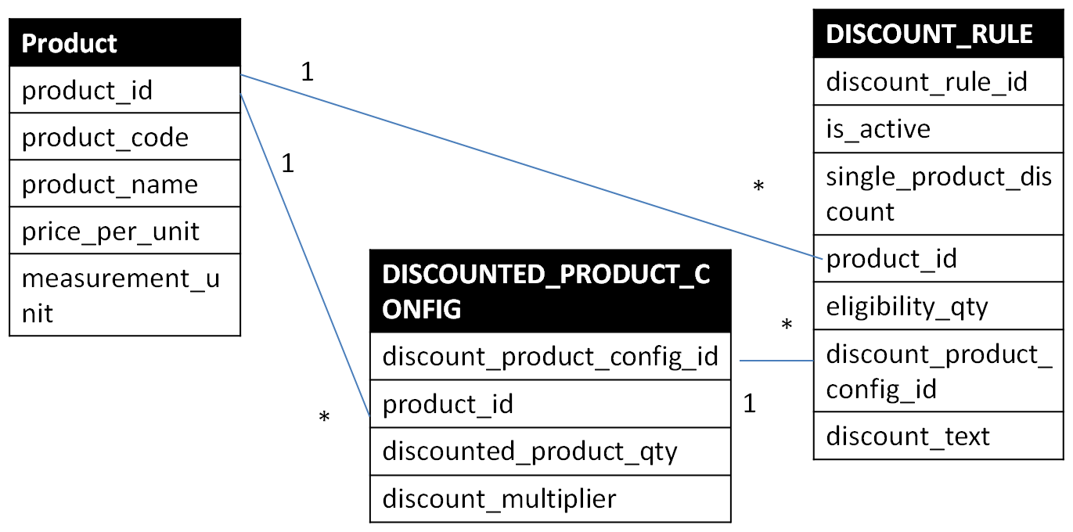

## Flow Diagram

1. List of products entered in command is accepted by BasketBillingClient and passes the list of products to BillingService
2. BillingService adds the products to the basket object for request. Basket is initialized with products and price details. Basket

BasketPriceCalculator calculates subtotal i.e. total without any discounts

1. Service passes basket to SingleProductDiscountCalculator. Single ProductDiscountCalculator calculates applicable single products discounts and passes basket to CombinationDiscountCalculator
2. CombinatioDiscountCalculator calculates combination discounts applicable for basket
3. Client calling BillWriter to print bill details on console

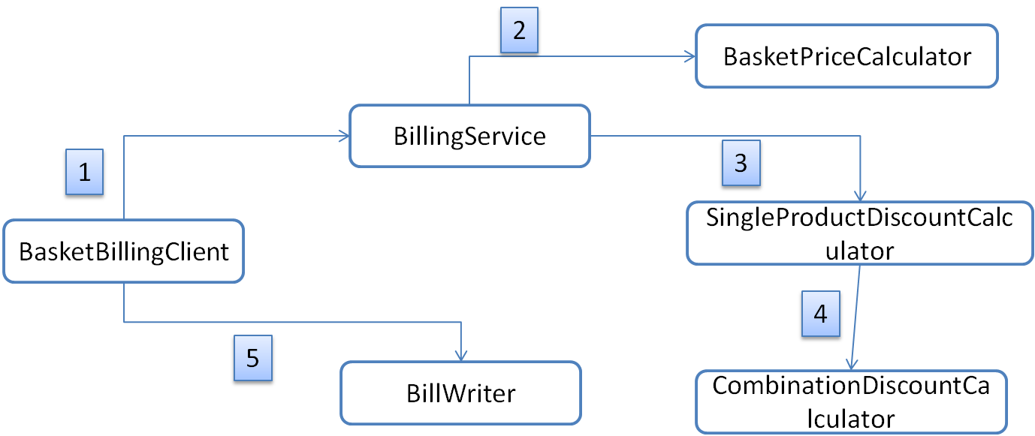

## Test Evidence

Billing Service Started

Please select from

1:Enter Basket Items

2:Exit

1

Please enter products list in format: PriceBasket item1 item2 item3 ...

Pricebasket Apples Apples

#########################

Subtotal: £2.00

Apples at 10% off: -0.20p

Total: £1.80

#########################

Please select from

1:Enter Basket Items

2:Exit

1

Please enter products list in format: PriceBasket item1 item2 item3 ...

PriceBasket Soup Soup Bread

#########################

Subtotal: £2.10

Bread loaf at 50% on 2 tins of soup: -0.40p

Total: £1.70

#########################

Please select from

1:Enter Basket Items

2:Exit

1

Please enter products list in format: PriceBasket item1 item2 item3 ...

PriceBasket Apples Soup Soup Bread

#########################

Subtotal: £3.10

Apples at 10% off: -0.10p

Bread loaf at 50% on 2 tins of soup: -0.40p

Total: £2.60

#########################

Please select from

1:Enter Basket Items

2:Exit

1

Please enter products list in format: PriceBasket item1 item2 item3 ...

PriceBasket Soup Soup Soup Soup Bread Bread Bread

#########################

Subtotal: £5.00

Bread loaf at 50% on 2 tins of soup: -0.40p

Bread loaf at 50% on 2 tins of soup: -0.40p

Total: £4.20

#########################

Please select from

1:Enter Basket Items

2:Exit

1

Please enter products list in format: PriceBasket item1 item2 item3 ...

PriceBasket

#########################

Subtotal: £0.00

(no offers available)

Total: £0.00

#########################

Please select from

1:Enter Basket Items

2:Exit

1

Please enter products list in format: PriceBasket item1 item2 item3 ...

PriceBasket Oranges Apples

#########################

Subtotal: £1.00

Apples at 10% off: -0.10p

Total: £0.90

#########################

#########################

Invalid Products : Oranges

#########################

Please select from

1:Enter Basket Items

2:Exit

3

Invalid Option Selected

Please select from

1:Enter Basket Items

2:Exit

2